Items to Have in Hand Leaving the Exchange:

- Privileged ATM card
- No Fees even out of the network
- DEPOSIT receipts for accounts
- Enough Checks for each Account
- NO – RFID chip or the card is provided with a sleeve that blocks RFID scanning
- Books of Checks (10) for each account
- Clean and Clear Funds Letter (Original and 10 Notarized copies)
- Proof of Funds Letter (Original and 10 Notarized copies)
- Copy of the signed NDA Banker must sign also!
- Complete Notary service
- Ask for Emergency Cash
- Bank to provide a team to include:
  - Tax Attorney,
  - CPA,
  - Private Wealth Manager,
  - Financial Planner,
  - Private Banker
- Print out clearly displaying ALL of the transactions with regards to these accounts

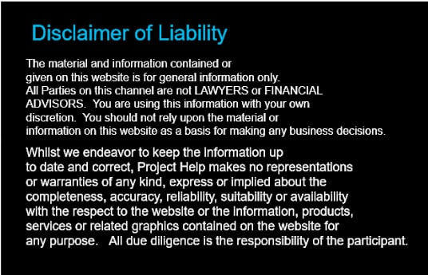

Bank Accounts must have the following restrictions:
- Flag all accounts as “ACCESS RESTRICTED TO NON-ESSENTIAL BANK PERSONEL”
- TAG ALL ACCOUNTS AS NON-TEST AND NON-TRANING ACCOUNTS
- Bank has NO POWER OF ATTORNEY
- Money Manager DOES NOT have complete fiduciary control over ANY of your money and must request authorization for any transaction as a security measure
- Absolutely No Investing in Blackrock/Aladdin or Carlisle without approval and complete terms review
Accounts must have the following features:
- NO Limitation of Time or Amounts, No Penalties, Charges or Fees on transfer or withdrawals of funds from any of the accounts
- NO Fees on checking or savings accounts
- NO ATM fees,
- NO human teller fees
- NO NON-System ATM fees
- NO debit or credit card fees
- NO Monthly Maintenance fee, Annual Maintenance fee, Service fee or Card fees for any purpose
- NO fee or charge for cashing any form of checks, free traveler’s checks
- NO Cash Advance fees
- NO Automatic withdrawals
- NO fees or charges for obtaining Certified Checks, Cashier’s Checks or Money Orders
- NO fees for Bill Pay
- NO Bank Spread or Currency Exchange fees
- NO Cashier’s Checks fees
- NO Annual Memberships fees
- NO Computer or Remote Banking without Multifactor authentication to verify access and notification of all failed access attempts

